Unit 4 The Internet and World Wide Web

The internet is a collection of a large number of computers connected together all over the world. By using internet we can look up information on any subject or send and receive messages through email. But we have to be careful about our safety while using the internet.

In this unit, we will also discuss the World Wide Web – the fastest growing area of the internet made up of millions of websites.

**Learning Objectives**

After completing this unit, students will be able to

* Define Internet
* Know what the internet offers
* Know about internet safety
* Know the principle means of connecting to the internet
* Dialup modem
* Broadband
* Wireless
* Cellular
* Explain the steps involved in accessing the internet
* Know the world wide web
* Know the web page
* Know the website
* Know the URL
* Know the web browser
* Use internet explorer
* Know the search engines
* Use different search engines
* Google
* Yahoo
* MSN

# Introduction to the Internet

Today we live in a world of technology, where internet spins a web of interconnectivity around the globe. Through [internet](https://www.informationq.com/what-is-internet/) billions of people around the world have been connected. Internet was evolved in 1969, under the project called **ARPANET** (Advanced Research Projects Agency Network) to connect computers at different universities and U.S. defense. Soon after, the people from different backgrounds such as engineers, scientists, students and researchers started using the network for exchanging information and messages.

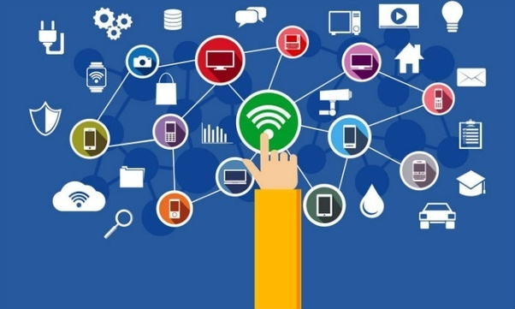

Figure 4.1 Introduction to internet

**4.1.1 Internet**

**Internet** is a global network of computer networks. It comprises of millions of computing devices that carry and transfer volumes of information from one device to the other. Desktop computers, mainframes, GPS units, cell phones, car alarms, video game consoles are connected to the internet.

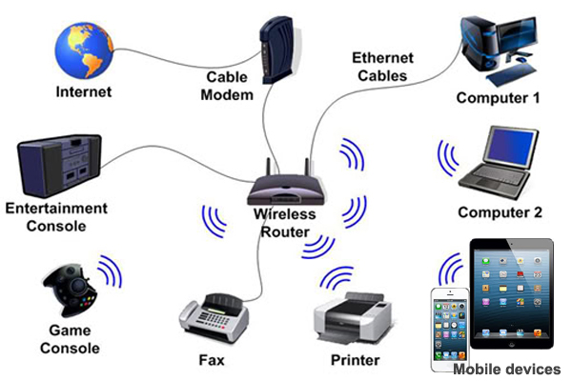

Figure 4.2.1 (a) Computing Devices

A **network** is a system of interconnected computers that communicate with one another and share application, data and hardware components.

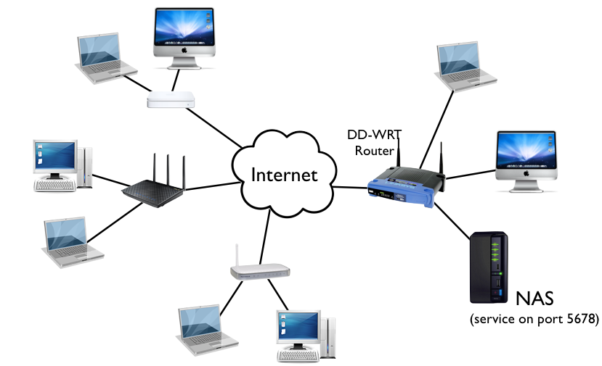

Figure 4.3.1 (b) A network example

DO YOU KNOW?

The new 2018 Global Digital suite of reports reveal that there are now more than 4 billion people around the world using the internet.



.

* + 1. **Internet Services**

The internet has become so important that its use is considered as the essential part of computer use. The most commonly used internet services are shown below

1. You can find out things on the World Wide Web.
2. 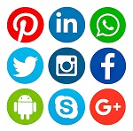You can use social networking services to connect with or build social relations with other people.
3. You can send email to people
4.  You can play games with people on the other side of the world.
5.  You can chat with your friends and family.
6.  You can buy things and have them delivered to your house.
7. 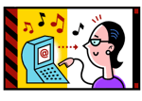You can listen to music and watch online videos.
8.  A user can access books and articles of any subject on the internet.
   * 1. **Internet Safety**

Remember these 5 SMART rules when using the internet and mobile phones.

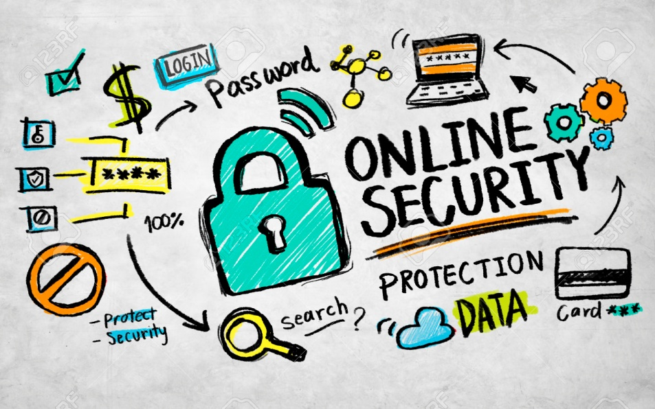

Figure 4.4.3 (a) Online Security

SAFE

Stay safe by being careful not to give out personal information such as your full name, email address, phone number, home address, photos or school name to people you are chatting with online.



Figure 4.5.3 (b) stay safe

MEET

Meeting someone you have only been in touch with online can be dangerous. Only meet someone with your parents’ permission and even then only when they are present.

ACCEPTING

Accepting emails, inbox messages or opening files, pictures or texts from people you don’t know or trust can lead to problems as they may contain viruses.

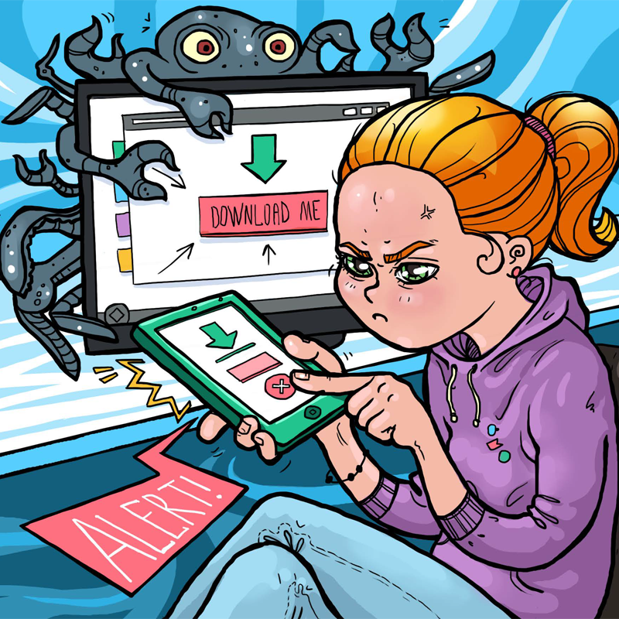

Figure 4.6.3 (c) Be careful while accepting files online

RELIABLE

Information that you find on the internet may not be true or someone online may be lying about who they are. Make sure you check the information before you believe it.



Figure 4.7.3 (d) Check reliability

TELL

Tell your parent or a trusted adult if someone or something makes you feel uncomfortable or worried, or if you or someone you know is being bullied online.

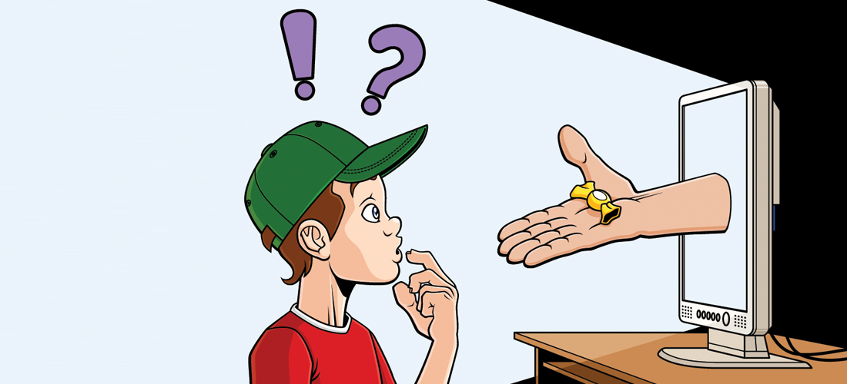

Figure 4.8.3 (e) Tell someone

DO YOU KNOW?

**National Response Centre for Cyber Crime (NR3C)** - FIA is a law enforcement agency dedicated to fight cyber crime in Pakistan. Inception of this Hi-Tech crime fighting unit transpired in 2007 to identify and curb the phenomenon of technological abuse in society

.

* + 1. **Means of Connecting to the Internet**

When a user wants to access internet, first of all he/she has to establish a connection of the computer to the internet. The connection is provided by a company which is known as **Internet Service Provider (ISP).** These connections can be wired or wireless.These ISPs offer different types of connections.

* **Telephone (dialup) modem**

**Dial-up connection** is a technology that helps a user to connect to the internet using standard phone lines. A user can access internet by plugging in telephone line in the modem. It is a slow speed and inexpensive technology. In this type of connection, telephone line remains busy and one cannot make any calls.

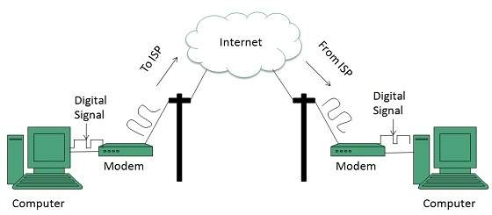

Figure 4.9.4 (a) Dialup Modem Setup

* + **Broadband**

Broadband Internet service truly is the most used form of Internet access because of its high access speeds. It is offered in four different forms

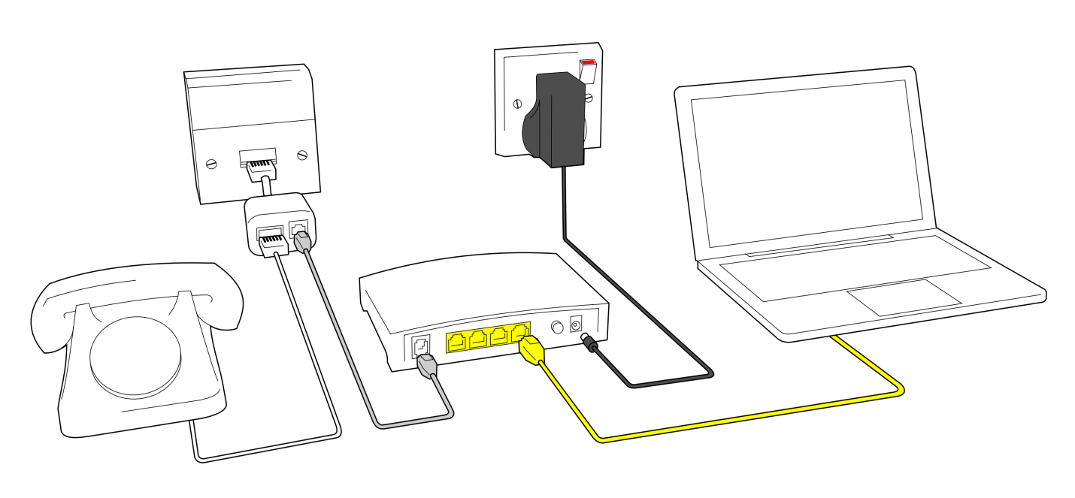 Figure 4.10.4 (b) Broadband Modem Setup

* **DSL (Digital Subscriber Line)**

**DSL** is a high speed internet technology that runs over standard phone lines. It is one of the fastest and most affordable types of internet connection. A DSL modem is connected to the computer with a network card. In DSL connection, telephone lines remain free to make calls.

* **Cable Modem**

**Cable modem service** is a technology that helps users in connecting to the internet using their cable TV wire. It provides a high speed connection as compared to the dial-up modems. It provides an “always ON” connection. It means that whenever a computer is powered on, the connection is ON. Cable modem can be connected to the computer with the network card.

* **Satellite**

Satellite accesses the internet via a satellite in Earth’s orbit. The enormous distance that a signal has to cover in travelling from earth to satellite and back again, provides a delayed connection as compared to the cable and DSL.

* **Fiber Optic**

The newest broadband service is **fiber-optic**, which is the fastest Internet connection thus far. However, this type of Internet service is still in its infancy as its service areas are quite limited and because the laying down of the fiber-optic cable takes a while to complete. Wherever it is available, the cost not only competes with that of DSL and cable, but it provides a much faster connection than both of those services.

DO YOU KNOW?

The $44 million **Optical Fiber Cable (OFC) project**, directly connecting Pakistan and China would be completed under the China Pakistan Economic Corridor (CPEC) by December 31, 2018, providing safest internet route to both countries.



.

* **Wireless**

**Wireless**, or **Wi-Fi**, as the name suggests, does not use telephone lines or cables to connect to the internet. Instead, it uses radio frequency. Wireless is also an always on connection and it can be accessed from just about anywhere.

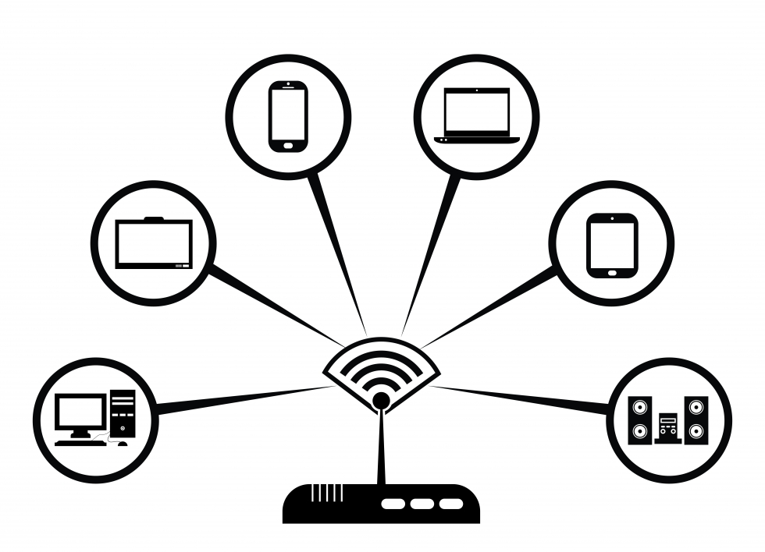

Figure 4.11.4 (c) Wifi

* **Cellular**

**Cellular technology** provides wireless Internet access through cell phones. The speeds vary depending on the provider, but the most common are 3G and 4G speeds.  A **3G** is a term that describes a 3rd generation cellular network obtaining mobile speeds of around 2.0 Mbps. **4G** is the fourth generation of cellular wireless standards. The goal of 4G is to achieve peak mobile speeds of 100 Mbps but the reality is about 21 Mbps currently.

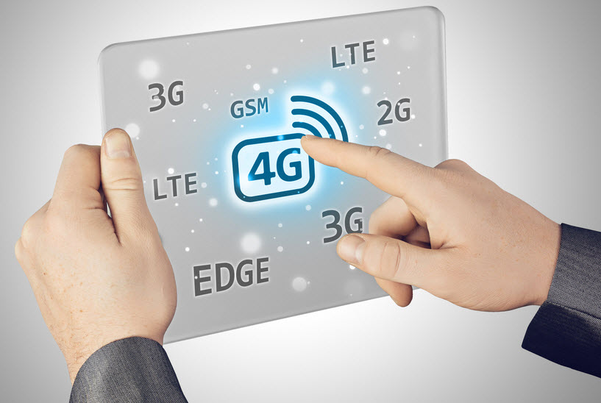

Figure 4.12.4 (d) Cellular Technology

DO YOU KNOW?

The number of 3G and 4G users in Pakistan has reached 53.24 million by the end of March 2018, according to the Pakistan Telecommunication Authority (PTA). 

.

* + 1. **Connecting to the Internet**

Following are the requirements for connecting to the internet.

1. **Computer**

A computer, tablet or a cell phone is an essential part for assessing the internet. We cannot access the internet without one of these devices.

1. **Modem**

A **modem** is a device which is used to connect and communicate with other computers.

* **Internal Modems**

An **internal modem** is a network device that is contained on an expansion board that plugs into the motherboard. Unlike an external modem, an internal modem contains no lights to inform the user of its current function or changing modem states. Internal modems are also known as on-board modems. Dial-up connection is an example of internal modem.

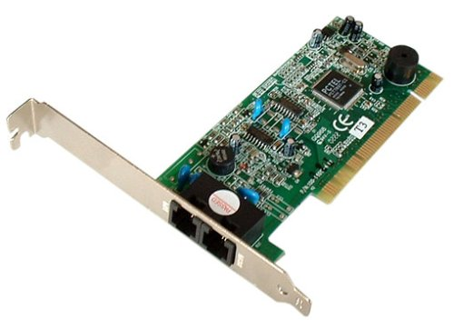

Figure 4.13.5 (a) Internal Modem

* **External Modems**

An **external modem** is similar to the internal modem in that it also allows access to the Internet, but unlike the internal modem, the external modem sits outside the computer

External modems have lights indicating various modem functions and they can easily be moved from one computer system to another. They do, however, require one COM or USB port to operate. Examples are DSL and cable modems.

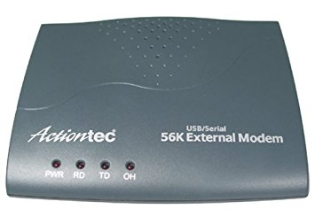

**Figure 4.14.5 (b) External Modem**

1. **Telephone / Cable TV Line**

A telephone line is required for a DSL or Dialup connection whereas a cable TV line is required for cable modem connections.

1. **Internet Service Provider (ISP)**

A company that provides an internet connection is known as **Internet Service Provider (ISP)**. Some of the leading ISPs in Pakistan are:

* PTCL (Pakistan Telecommunication Limited)
* Wi-tribe
* COMSATS Internet Services
* Qubee
* Wateen

1. **Web Browser**

A **Web browser** is a software which is used to access and view different websites. Some popular web browsers are:

* Mozilla Firefox
* Google Chrome
* Opera
* Safari
* Microsoft Edge
* Microsoft Internet Explorer

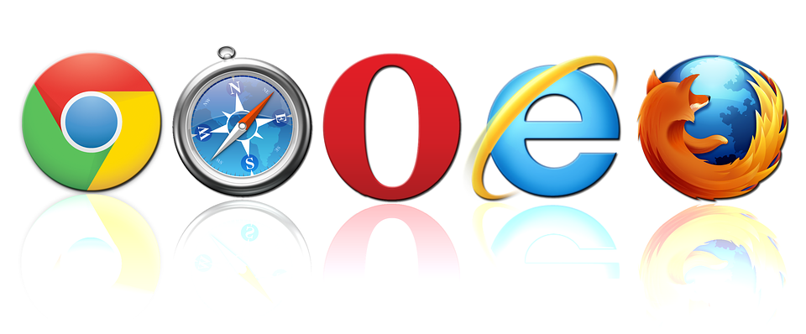

**Figure 4.15.5 (c) Web Browsers**

# World Wide Web (The Web)

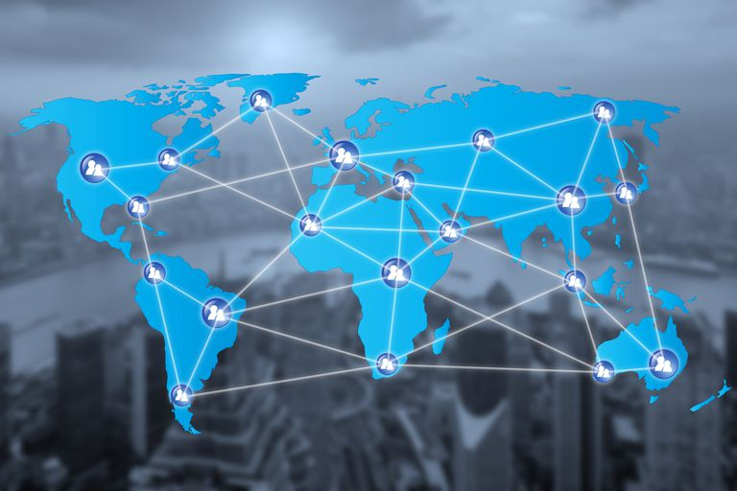

**Figure 4.2 World Wide Web**

History of World Wide Web

The [World Wide Web](https://www.informationq.com/about-the-world-wide-web-and-identifying-a-hyperlink/) was invented by Tim Berners-Lee in 1989. He wrote the first [web browser](https://en.wikipedia.org/wiki/Web_browser) in 1990 while employed at [CERN](https://en.wikipedia.org/wiki/CERN) in Switzerland. The browser was released outside CERN in 1991, first to other research institutions starting in January 1991 and to the general public on the Internet in August 1991.

Since that time, the web has changed the world. It has perhaps become the most powerful communication medium the world has ever known.

DO YOU KNOW?

Internet and Web is not the same thing: Web uses internet to pass over the information to the users.



.

*Definition of World Wide Web*

## The World Wide Web is part of the Internet. It is a collection of millions of pages of information. This information can include texts, pictures, animations, sounds and video, and it can be about anything. In simple terms, The World Wide Web is a way of exchanging information between computers on the Internet.

* + 1. **Web Page**

**Web page** is a document available on World Wide Web. A web page can contain huge information including text, graphics, audio, video and hyper links. **Hyper links** are the link to other web pages. Web Pages are stored on web server and can be viewed using a web browser. There are two types of web pages:

* **Static Web Pages**

**Static web pages** are also known as flat or stationary web page. Such web pages contain only static information. User can only read the information but cannot do any modification or interact with the information.

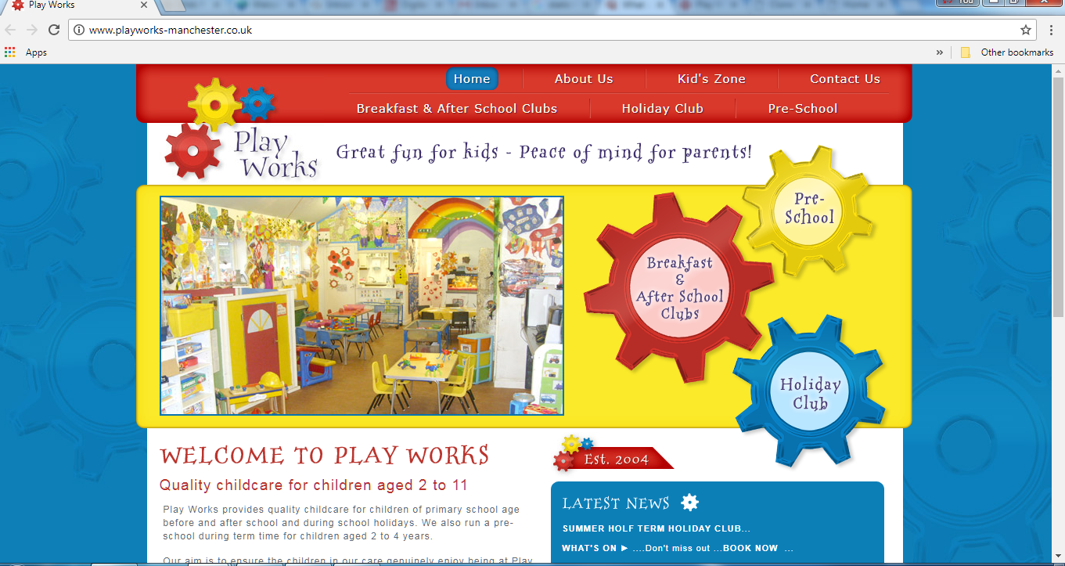

**Figure 4.2.1 (a) Static web page**

* **Dynamic Web Pages**

**Dynamic web page** shows different information at different point of time. It is possible to change a portion of a web page without loading the entire web page.

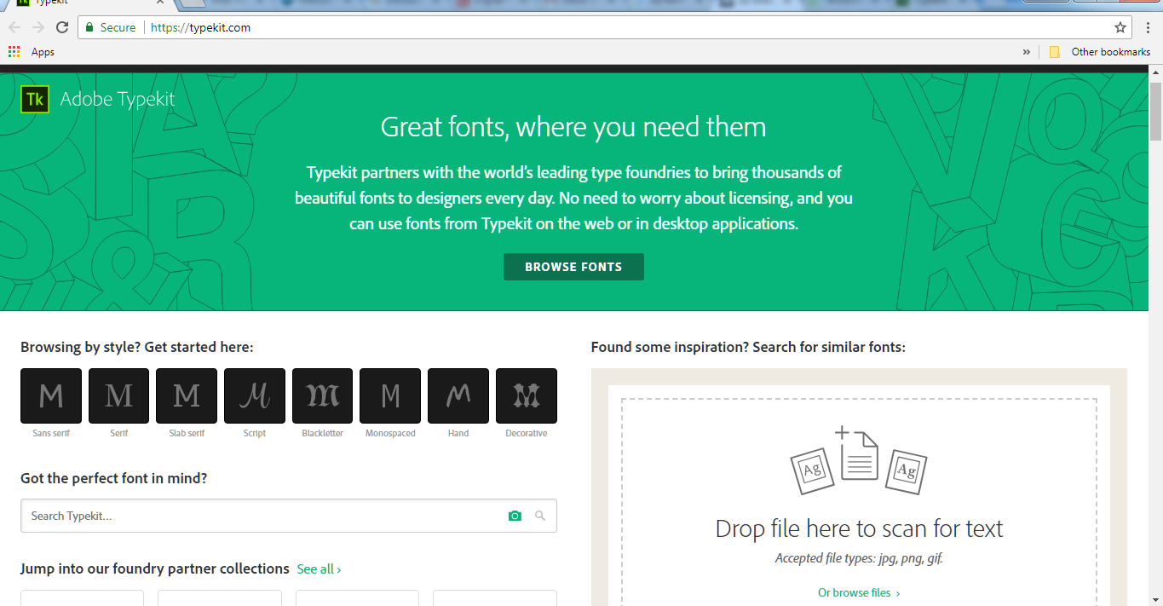

**Figure 4.2.1 (b) Dynamic web page**

* + 1. **Website**

A **website** is a collection of related web pages. Each website contains a number of documents and files. The first page of a website is known as **home page.** It serves as an introduction of the entire website. A user can access any website in the world by writing its address in the address bar of the Web Browser. He/she can move from one web page of the website to another by clicking on the hyper-links. Figure 4.2.2 (a) shows the home page for w3schools online web tutorials website.

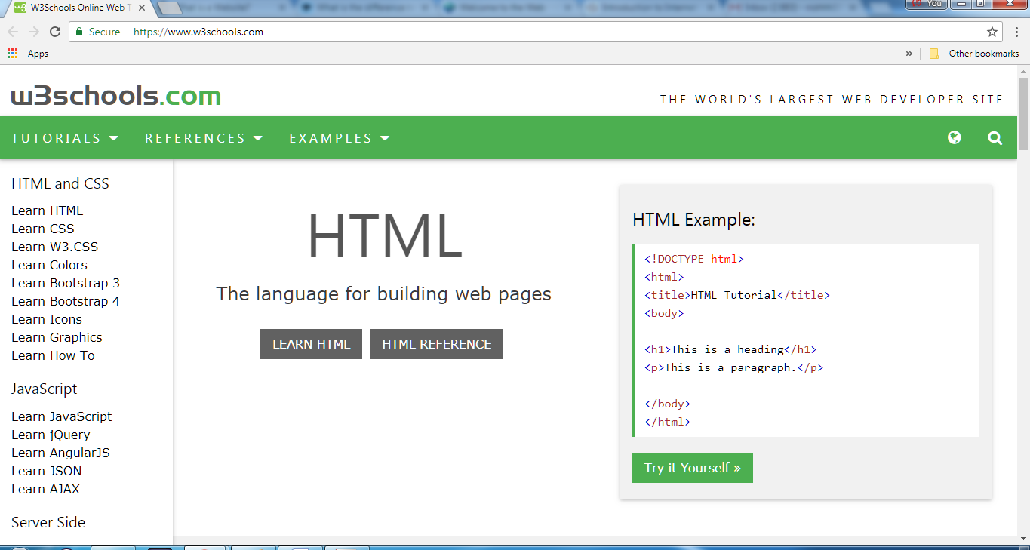 **Figure 4.2.2 (a) w3schools home page**

When you click on *Learn HTML* button on the home page, it opens another web page for HTML tutorial.

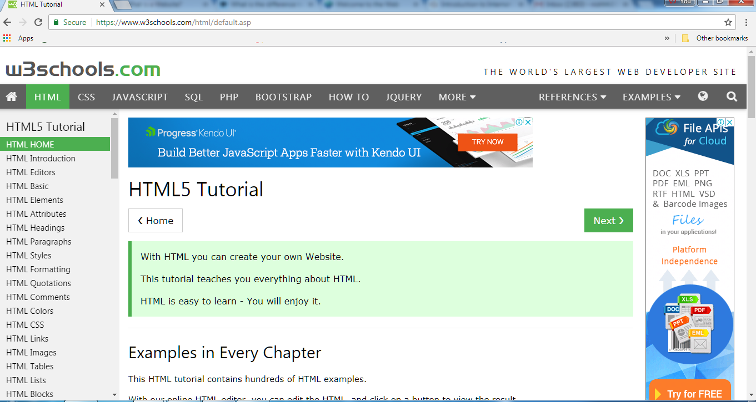 **Figure 4.2.2 (b) HTML tutorial webpage**

* + 1. **Uniform Resource Locator (URL)**

**URL (Uniform Resource Locator)** is the address of a webpage on the internet. Every web page has a unique address. A webpage can only be accessed if we know the URL of that page. For example Google is one of the most popular websites and its URL is <https://www.google.com/>

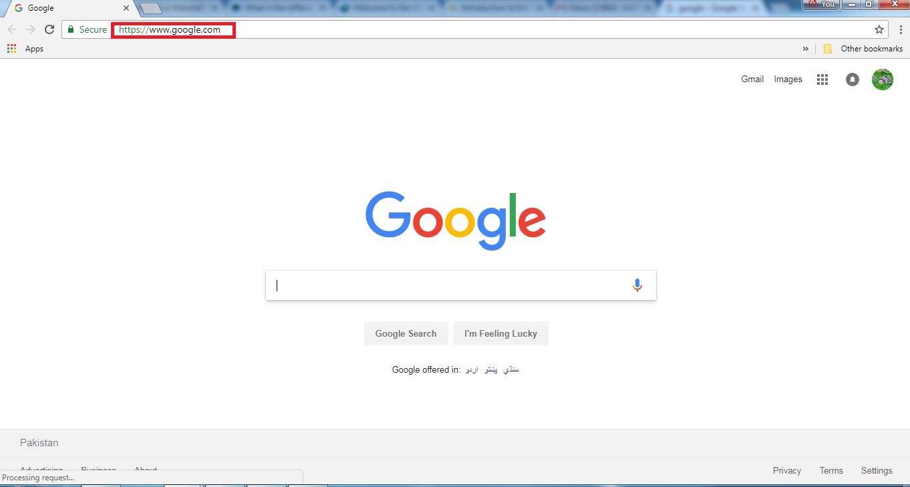

**Figure 4.2.3 Google home page**

DO YOU KNOW?

If you look at the address bar you will notice that for some websites URL begins with “*http://*” whereas for others it starts with “*https://*” The main difference between these two is that http:// is considered to be unsecure while https:// is considered to be secure.

.

* + 1. **Web Browser**

**Web Browser** is a software that is used to access the World Wide Web. We can access and view different web pages or websites using a web browser. A good web browser is user friendly. We can type the URL of any website in its address bar and the browser will show that particular website. Microsoft Internet Explorer, Mozilla Firefox, Google Chrome and Safari are some of the most popular web browsers.

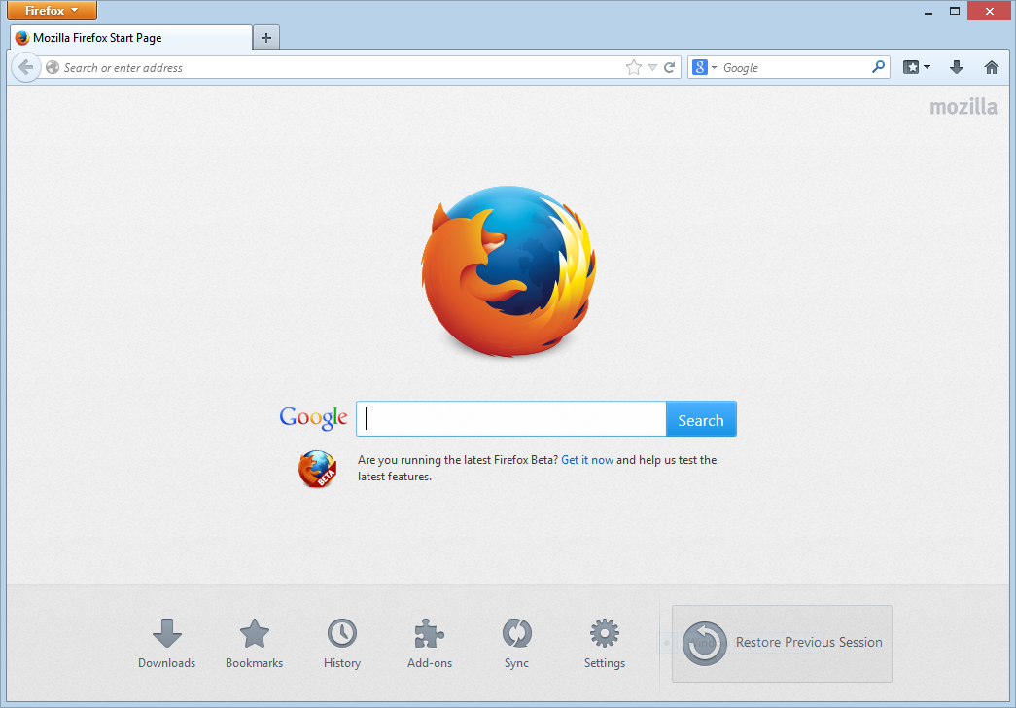 **Figure 4.2.4 (a) Mozilla Firefox**

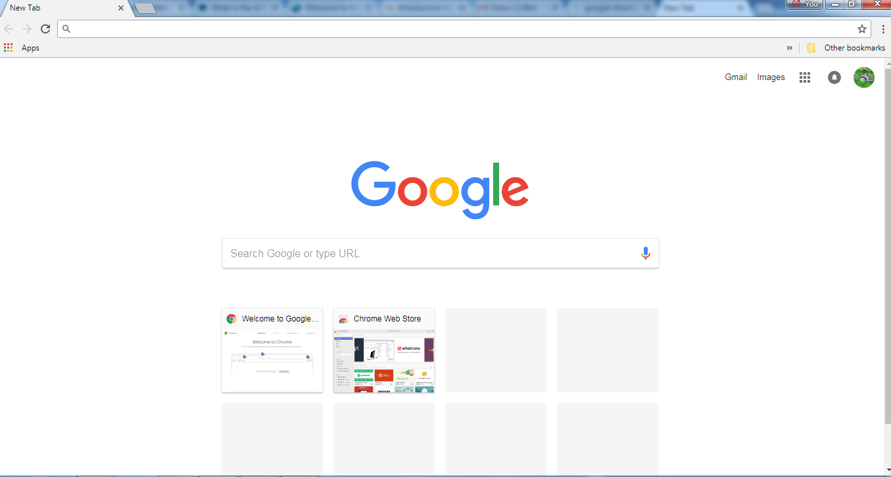 **Figure 4.2.4 (b) Google Chrome**

* + 1. **Internet Explorer**

In windows, the software which serves as a web browser is known as **internet explorer.** It has different menus, buttons and icons to help a user access different websites and web pages.

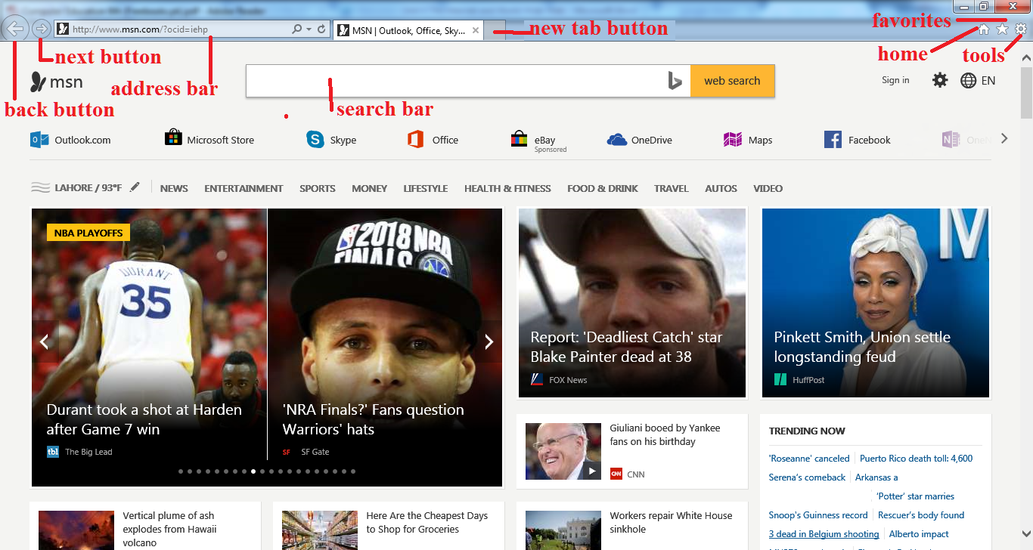

**Figure 4.2.5 Internet explorer**

* **Address Bar**

You can type the URL of the desired website here.

* **Refresh Button**

The webpage is reloaded on clicking this button.

* **Next and Back Buttons**

These buttons are used to move to the next or previous webpage of a website.

* **New Tab Button**

A new tab window opens by clicking this button.

* **Home Button**

This button takes you back to the home page of internet explorer.

* **Favorites Button**

You can view favorites by clicking on this button.

* **Tools Button**

It contains list of tools such as Print, file, zoom etc.

DO YOU KNOW?

**Microsoft Edge** is a [web browser](https://en.wikipedia.org/wiki/Web_browser) developed by [Microsoft](https://en.wikipedia.org/wiki/Microsoft) and included in [Windows 10](https://en.wikipedia.org/wiki/Windows_10), [Windows 10 Mobile](https://en.wikipedia.org/wiki/Windows_10_Mobile) and [Xbox One](https://en.wikipedia.org/wiki/Xbox_One), replacing [Internet Explorer](https://en.wikipedia.org/wiki/Internet_Explorer) as the default web browser on all device classes.

.

* + 1. **Accessing Different Web Pages using Internet Explorer**
* Open Internet Explorer by clicking on the Internet Explorer icon in the *taskbar*.

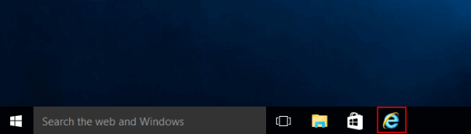**Figure 4.2.6 (a) Internet Explorer icon**

* Type the URL [www.google.com](http://www.google.com) in the address bar.

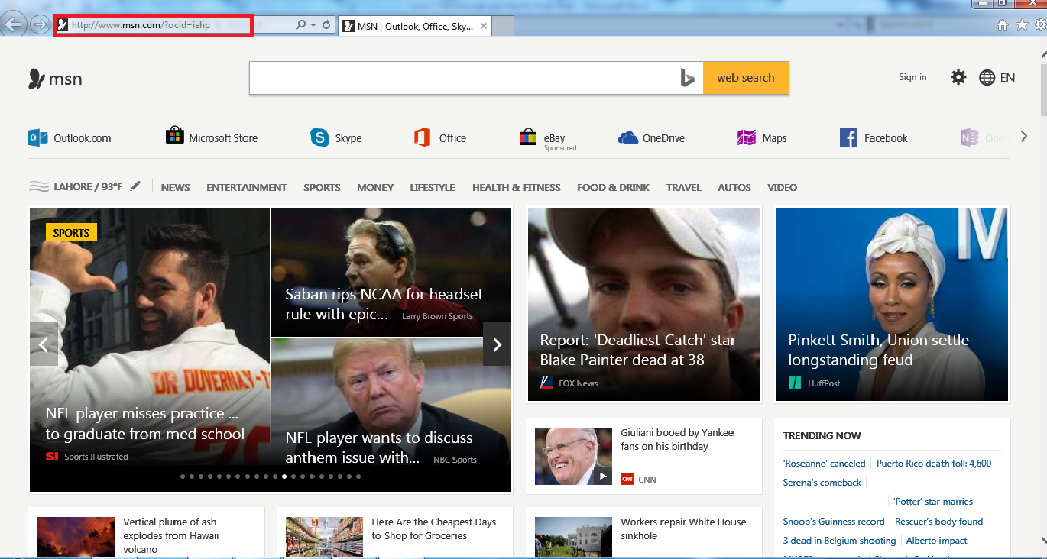 **Figure 4.2.6 (b) Write URL in address bar**

* Press Enter key.
* The home webpage of Google website will appear.

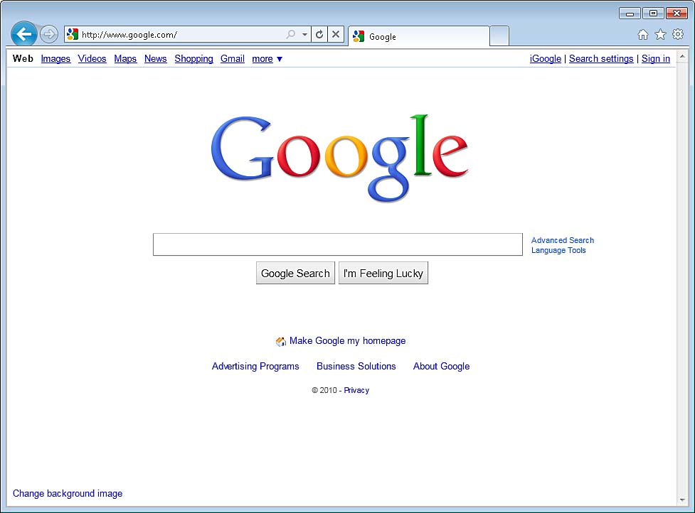**Figure 4.2.6 (c) Internet Explorer (Google)**

Try It Yourself!

* Open Internet Explorer
* Now one by one type the following addresses

in the address bar.

* + [www.yahoo.com](http://www.yahoo.com)
  + [www.typingtutor.org](http://www.typingtutor.org)
  + [www.w3schools.com](http://www.w3schools.com)
  + [www.wikipedia.org](http://www.wikipedia.org)
  + [www.wikihow.com](http://www.wikihow.com)



* + 1. **Search Engines**

**Search Engine** is a program that is used to find web pages and websites on the internet. When we type a word or a phrase, the search engine will show a list of websites with related information. Some of the most popular search engines are listed below

* Google ([www.google.com](http://www.google.com))
* Yahoo ([www.yahoo.com](http://www.yahoo.com))
* Ask ([www.ask.com](http://www.ask.com))
* Bing ([www.bing.com](http://www.bing.com))
* MSN ([www.msn.com](http://www.msn.com))

Web search engines work with the help of two programs, **Spider** which fetches as many documents as possible. Another program, called an **indexer**, reads the documents and creates an index based on the words contained in each document. Each search engine uses an algorithm to create its indices such that, only related results for specified keywords is stored and returns a list of the documents where the keywords were found.

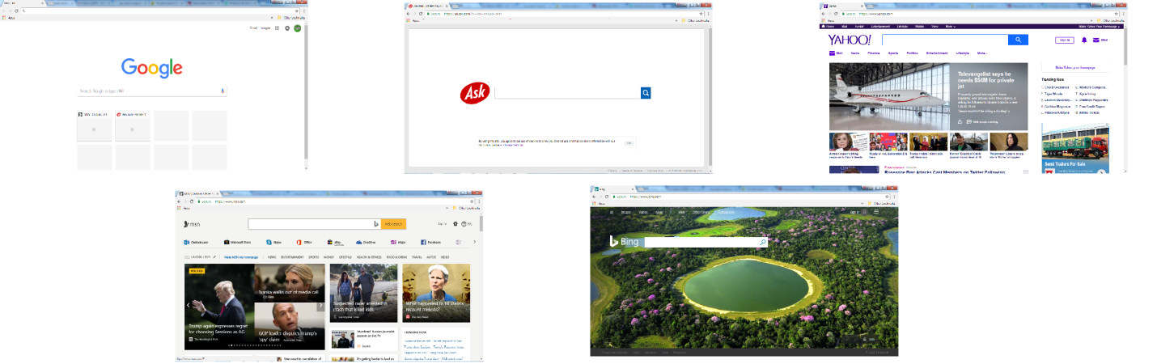 **Figure 4.2.7 Search engines**

* + 1. **Using Search Engines**

Using Google

* Open Internet Explorer, Google Chrome or any other web browser installed on your computer.
* The *home page* of the browser will open. By default the home page of *Google Chrome* is set to *Google Search.*

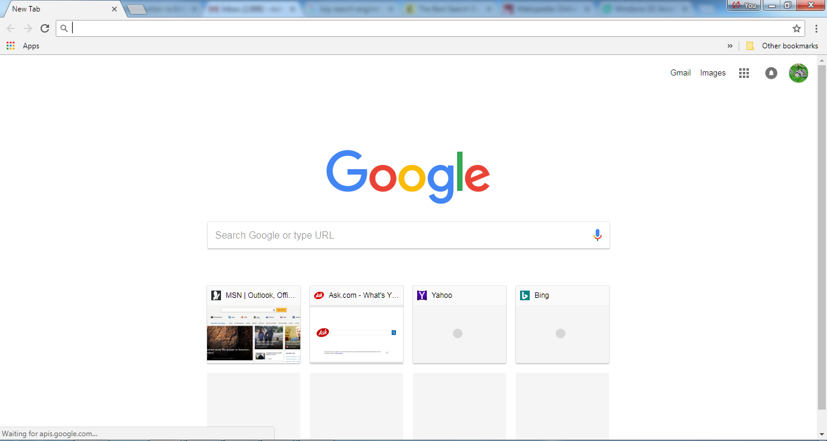 **Figure 4.2.8 (a) Google Search engine**

* Type “Pakistan news” in the search bar and press Enter.
* List of related web pages or websites will appear.

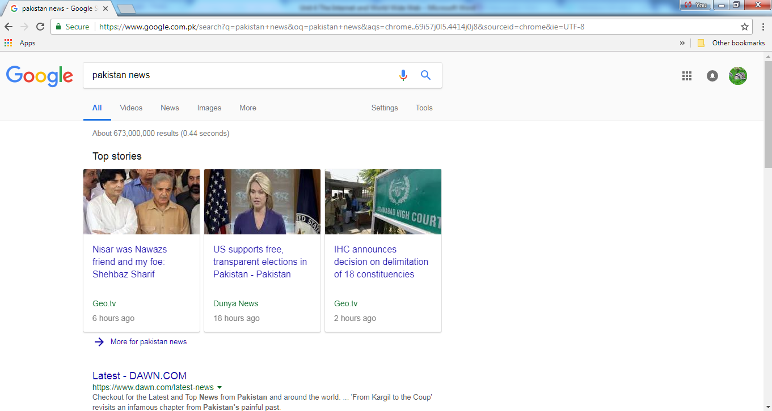 **Figure 4.2.8 (b) list of related results**

Using Yahoo

* Open Internet Explorer, Google Chrome or any other web browser installed on your computer.
* The *home page* of the browser will open. By default the home page of *Google Chrome* is set to *Google Search.*
* Type the URL [www.yahoo.com](http://www.yahoo.com) in the address bar and press Enter.
* Yahoo home page will appear.

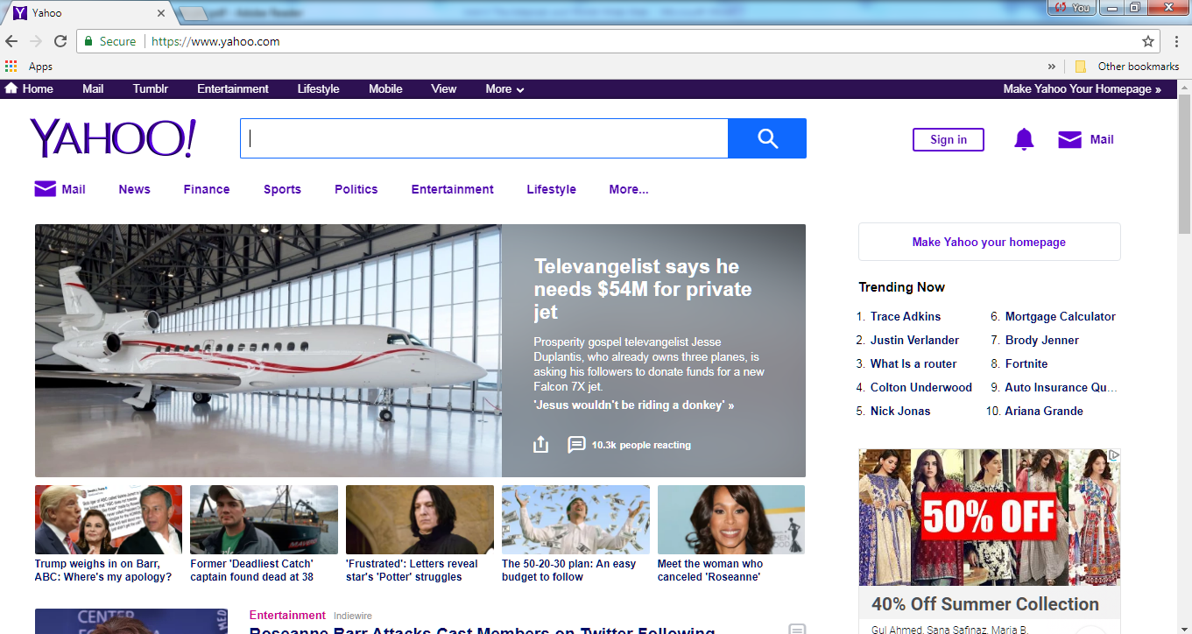**Figure 4.2.8 (c) Yahoo Search engine**

* Type “Pakistan news” in the search bar and press Enter.
* List of related web pages or websites will appear.

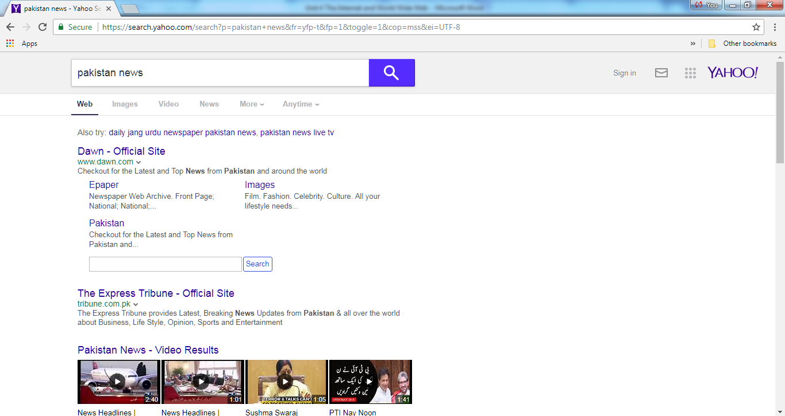 **Figure 4.2.8 (d) List of related results**

Using MSN

* Open Internet Explorer, Google Chrome or any other web browser installed on your computer.
* The *home page* of the browser will open. By default the home page of *Internet Explorer* is set to *MSN.*
* MSN home page will appear.

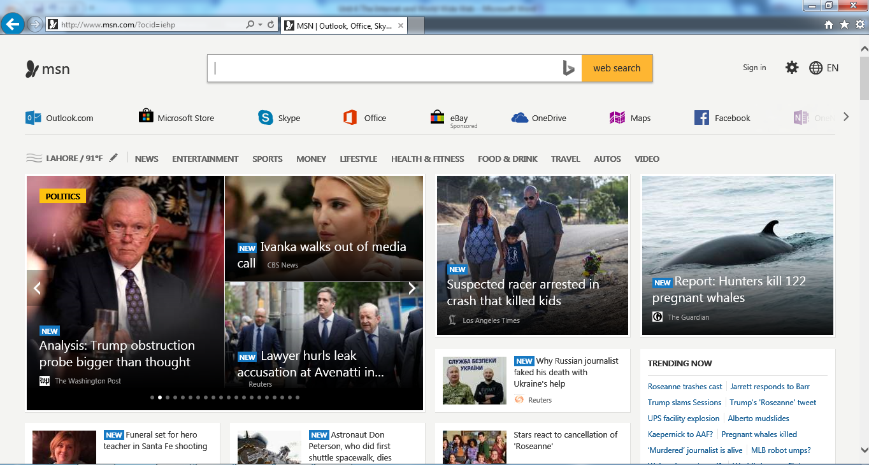

**Figure 4.2.8 (e) MSN search**

* Type “Pakistan news” in the search bar and press Enter.
* List of related web pages or websites will appear in a new tab.

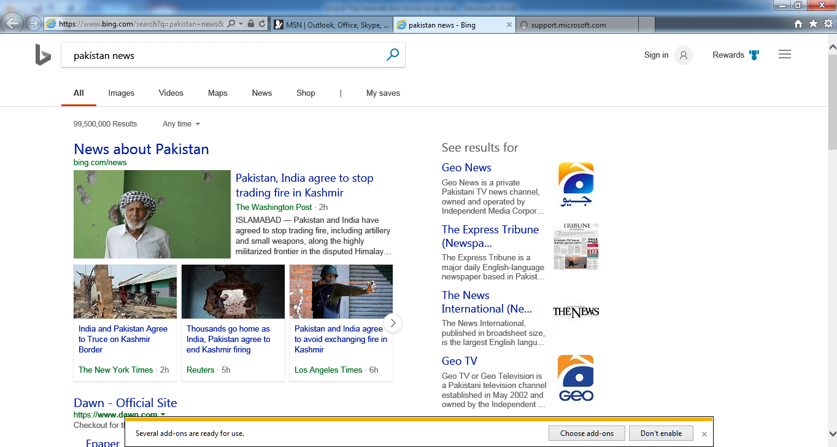**Figure 4.2.8 (f) List of related results**

SUMMARY

* **Internet** is a global network of computer networks.
* A **network** is a system of interconnected computers that communicate with one another and share application, data and hardware components.
* Stay safe online by following the 5 SMART rules while using the internet.
* **Dial-up connection** is a technology that helps a user to connect to the internet using standard phone lines.
* **DSL** is a high speed internet technology that runs over standard phone lines
* **Cable modem service** is a technology that helps users in connecting to the internet using their cable TV wire
* Satellite accesses the internet via a satellite in Earth’s orbit.
* The newest broadband service is **fiber-optic**, which is the fastest Internet connection thus far.
* **Wireless** or **Wi-Fi** does not use telephone lines or cables to connect to the internet. Instead, it uses radio frequency.
* **Cellular technology** provides wireless Internet access through cell phones.
* A **modem** is a device which is used to connect and communicate with other computers.
* A company that provides an internet connection is known as **Internet Service Provider (ISP)**.
* The World Wide Web was invented by Tim Berners-Lee in 1989.
* The **World Wide Web** is part of the Internet. It is a collection of millions of pages of information. This information can include texts, pictures, animations, sounds and videos.
* **Web page** is a document available on World Wide Web.
* A **website** is a collection of related web pages. Each website contains a number of documents and files.
* **URL (Uniform Resource Locator)** is the address of a webpage on the internet.
* **Web Browser** is a software that is used to access the World Wide Web.
* In windows, the software which serves as a web browser is known as **internet explorer.**
* **Search Engine** is a program that is used to find web pages and websites on the internet.

EXERCISE

## Q.1 Tick the right choice

1. __________ is a global network of computer networks.

a) Internet b)Intranet c) network d)Group

1. More than _________ people around the world are using the internet.

a) 8 billion b) 6 billion c) 4 billion d) 5 billion

1. _____________ is a slow speed and inexpensive technology.

a) Wifi b) dial-up connection c) DSL d) Fiber-optic connection

1. A **________** is a device which is used to connect and communicate with other computers.

a) modem b) telephone c) fax machine d) printer

1. Which of the following is an Internet Service Provider (ISP)?

a) PTBB b)PTCL c)PEMRA d) WAPDA

1. The software used to access and view web pages is called ________

a)Web server b)Web browser c) Web explorer d)Web linker

1. WWW stands for _________________

a)World Wide West b)World With Web c)World Wide Web d)World Wide Work

1. ______________ is the address of a webpage on the internet

a) UOL b)UCL c)UDL d)URL

1. In Internet Explorer, the webpage is reloaded on clicking _______ button

a) refresh b) home c) favorites d) tools

1. Search Engines use a program **__________** which reads the documents and creates an index based on the words contained in each document.

a) spider b) scheduler c) indexer d) sorter

1. The home page of Google Chrome is set to __________

a) MSN b) ASK.com c) Google search d)Google Scholar

1. ____________ is a search engine

a)Bing b)typing master c)wikihow d)w3schools

1. Safari is a ___________

a) web browser b) website c) search engine d) program

1. The first page of a website is known as _______ page

a) web b) home c) tools d)settings

1. **_______ web page** shows different information at different point of time

a) static b)home c)dynamic d)interacting

## Q.2 Fill in the blanks

1. Internet was evolved in 1969, under the project called _________
2. A **_________** is a system of interconnected computers that communicate with one another and share application, data and hardware components.
3. You can use _____________ services to connect with or build social relations with other people.

1. NR3C is a law enforcement agency dedicated to fight _________ in Pakistan.
2. **______** is a term that describes a 3rd generation cellular network.
3. An **______________** is a network device that is contained on an expansion board that plugs into the motherboard.
4. A **___________** is a software which is used to access and view different websites.
5. The World Wide Web was invented by ______________ in 1989.
6. **_______________** are also known as flat or stationary web pages.
7. In windows, the software which serves as a web browser is known as **______________.**
8. Web search engines work with the help of a program **_________** which fetches as many documents as possible.
9. A good web browser is _____________.

## Q.3 Define the following

1)Internet 2)World Wide Web 3) URL 4)Web browser 5) Search engine 6)ISP

## Q.4 Give brief answers to the following questions

1. Name and explain five internet services.
2. What are the SMART rules for internet safety?
3. What are the requirements for connecting to the internet?
4. What is a webpage? briefly explain its types.
5. Write down the steps for accessing different web pages using Internet explorer.
6. Define and explain a search engine.
7. Write down the steps for searching “Pakistan cricket” on Yahoo search engine.
8. Define modem and explain its types.
9. Define and explain broadband internet service.
10. Write names and URLs of five different search engines.

## Q.5 Differentiate between the following

1)internet and world wide web

2)web page and website

3)telephone modem and cable modem

4)web browser and search engine

5)Dynamic and static webpages

## Q.6 Label the following diagram

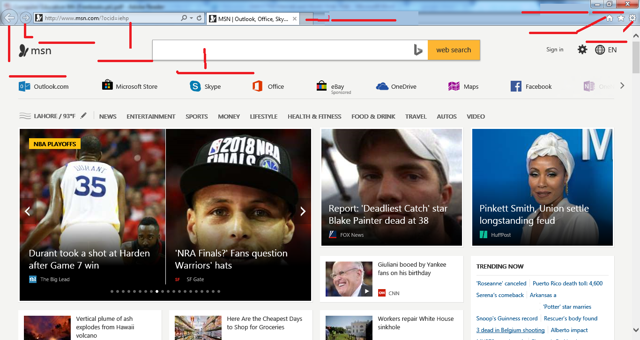

## Q.7 Label the following diagram

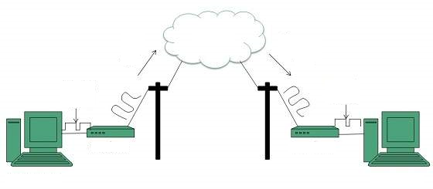

## Q.8 Match column A with column B and write the matching pairs in column C

|  |  |  |
| --- | --- | --- |
| Column A | Column B | Column C |
| 1. ARPANET | a) fastest internet connection |  |
| 1. network | b) Google Search |  |
| 1. Email | c)World Wide Web |  |
| 1. DSL | d)system of interconnected computers |  |
| 1. Fibre optic | e) Web browser |  |
| 1. Qubee | f) Advanced Research Projects Agency Network |  |
| 1. Opera | g) Digital Subscriber Line |  |
| 1. URL | h) internet service |  |
| 1. Google Chrome | i) ISP |  |
| 1. WWW | j) Uniform Resource Locator |  |

**Lab Activity 1**

1. With the help of your teacher, find out the type of modem and connection used to provide internet in your computer lab.
2. What is the name of your ISP?

**Lab Activity 2**

* Open your web browser
* Open the website for scratch programming. Its URL is <https://scratch.mit.edu/>
* Click and open any “hyperlink”

**Lab Activity 3**

* Open your web browser
* Open “Yahoo” search engine
* Type “top 5 computer games” in the search bar
* Click on the first link that appears on top of the results
* Make a list of top 5 computer games on a paper

**Lab Activity 4**

* Open your web browser
* Open the following websites by writing their URLs in address bar one by one.
* Look at the homepage of each website
* With your teacher’s help write in front of each website’s name if it is a static or dynamic webpage.

**Website Static/Dynamic**

1. <https://www.mint.com/> _____________________
2. <https://www.dropbox.com/> _____________________
3. <https://www.amazon.com/> ______________________
4. <https://www.daraz.pk/> ______________________